Beacon Labs - Lab Report

Name: INSTRUCTOR | Date: (Date of lab completion)
Lab Name: VenomAttack Lab

Setup:
(Description of the task and how you completed it. Include words and images as necessary)

Objective of this lab

Activity hijacking attacks were once one of the most powerful attacks against Android devices, but thanks to the presence of new effective defense mechanisms, they typically no longer pose security threats in more recent versions. In this exercise however, we explore a new state-of-the-art automated and adaptive hijacking attack that utilizes a spectrum of customized attacks. Specifically, we explore the use of hot patch techniques to identify vulnerable devices and update attack payload without the need for re-installation/re-distribution. Furthermore, we utilize this service to receive a list of installed applications from the device via a remote server in order to determine a target application and recreate it utilizing an automated UI-generator tool known as Appium. This lab is based off of the paper VenomAttack: Automated and Adaptive Activity Hijacking in Android, by P. Sun, S. Chen, L. Fan, P. Gas, F. Song, and M. Yang.

Task Set 1:
(Description of the task and how you completed it. Include words and images as necessary)

Task 1.1: Getting Device Information
Action 1.1.1
Log to the console a list of installed packages along with the device resolution and submit a screenshot of both your output and your code.
Using getInstalledPackaegs:
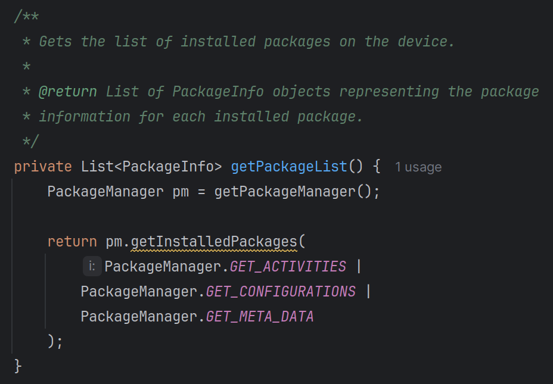
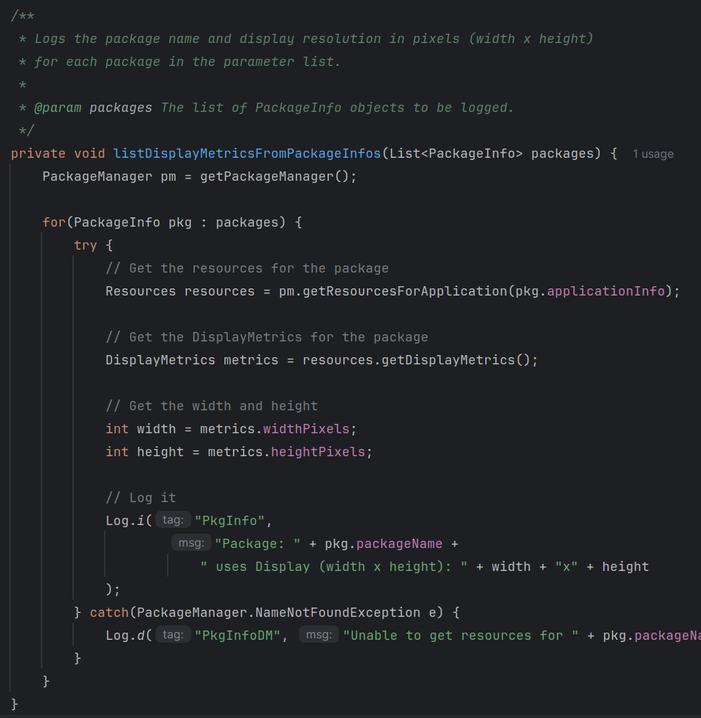

Using getInstalledApplications:
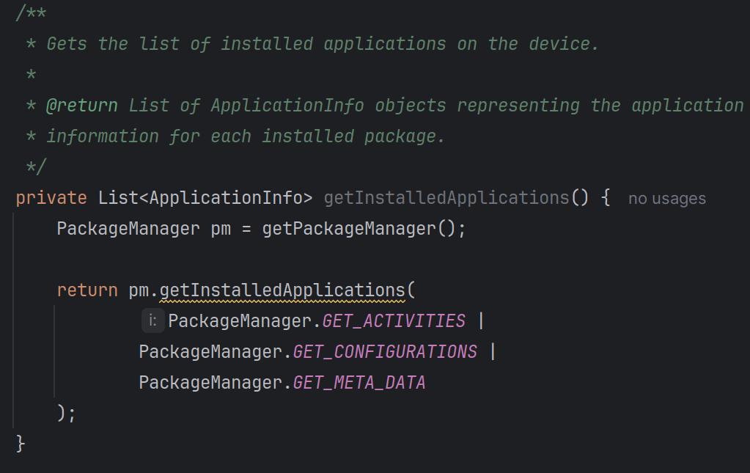
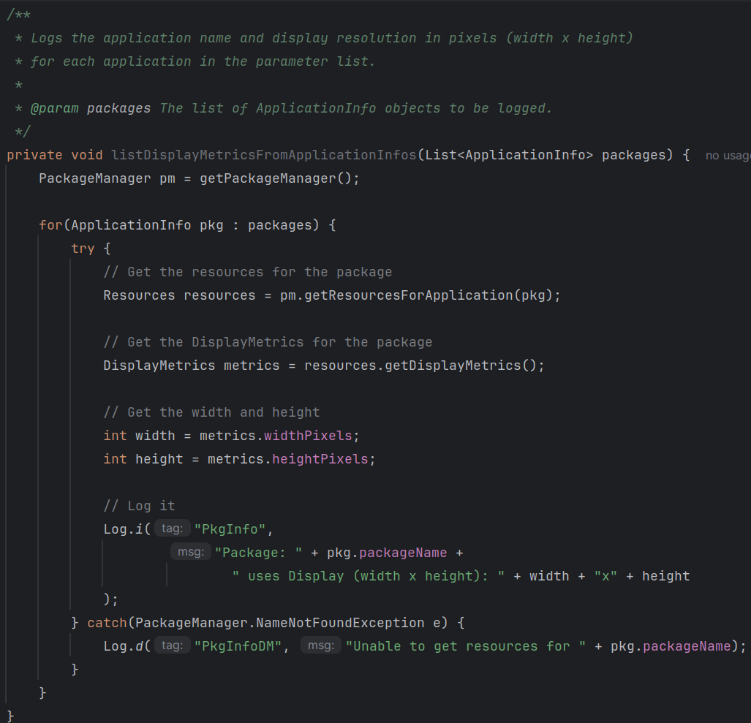
Output log will look like the following:
“com.ispm.app usses Display (width x height): 1080x2340”

Another way is the following:
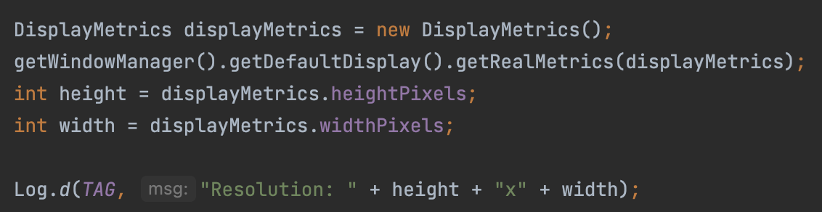
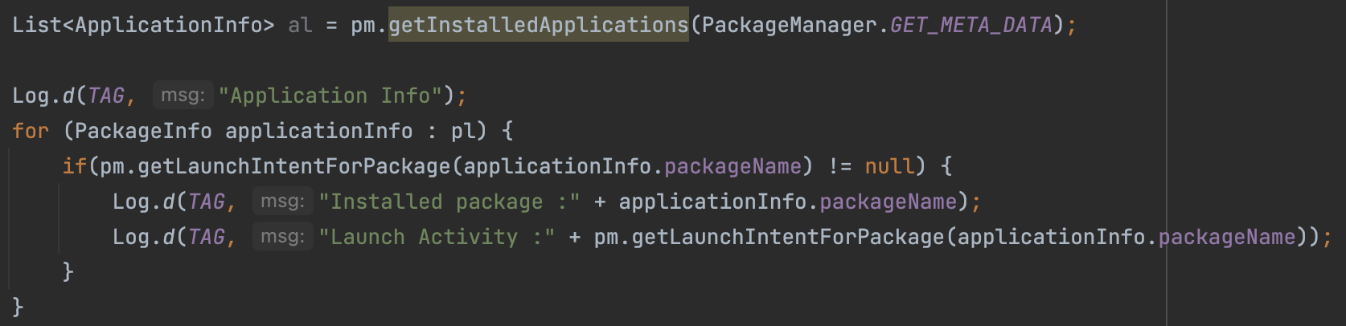
Action 1.1.2
What is one way you might be able to filter out some undesirable applications from the list of package names?
- Examples:
- Remove any packages with a null launch activity
- Filter out undesirable packages by name
Example implementation of this:
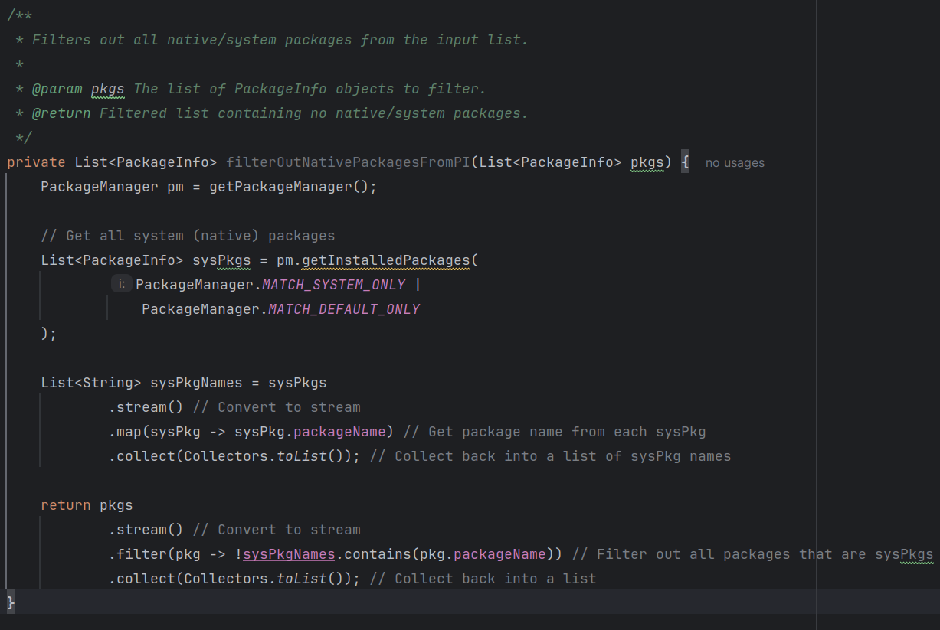
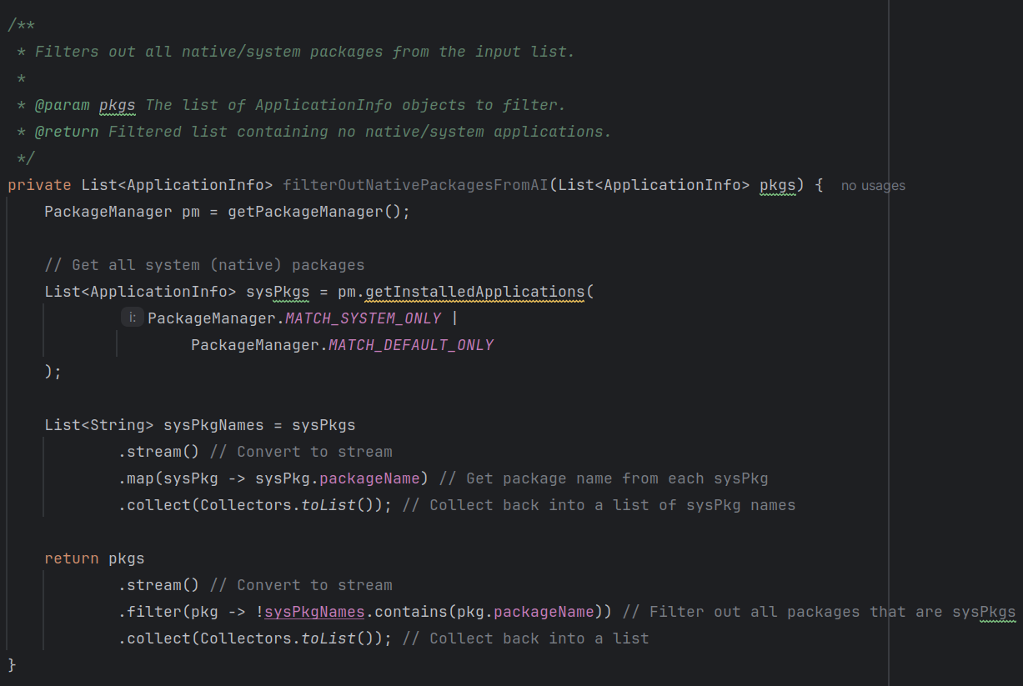
Task 1.2: Creating the Remote Server
Action 1.2.1
Create an active Node.js server and connect to it via the localhost address in your browser. Submit a screenshot of the output of this page along with the output in your terminal logging what port your server is listening on.

Following along the provided video walks through the exact steps necessary.

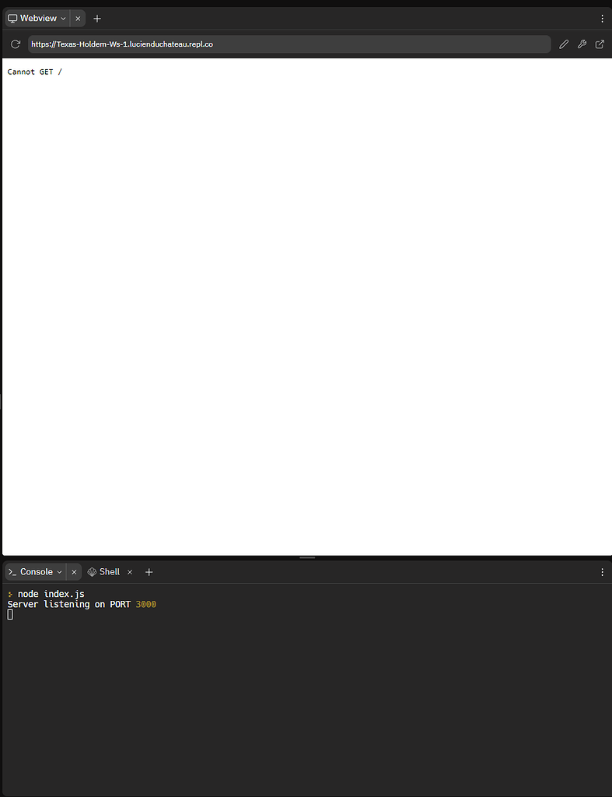

Task 1.3: Connecting and Communicating w/ the Remote Server
Action 1.3.1
Create an active connection to the remote server and submit a screenshot of your server log logging the socket connection.

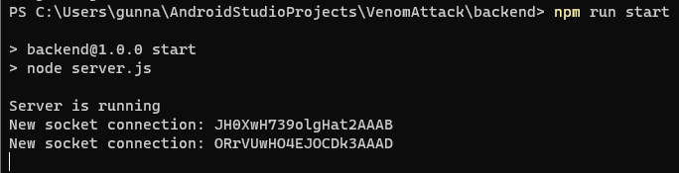

Action 1.3.2
Send over the device information retrieved from your application, log it out to the console, and submit a screenshot that shows: your socket connection, your device resolution, and a list of package names installed on the device.
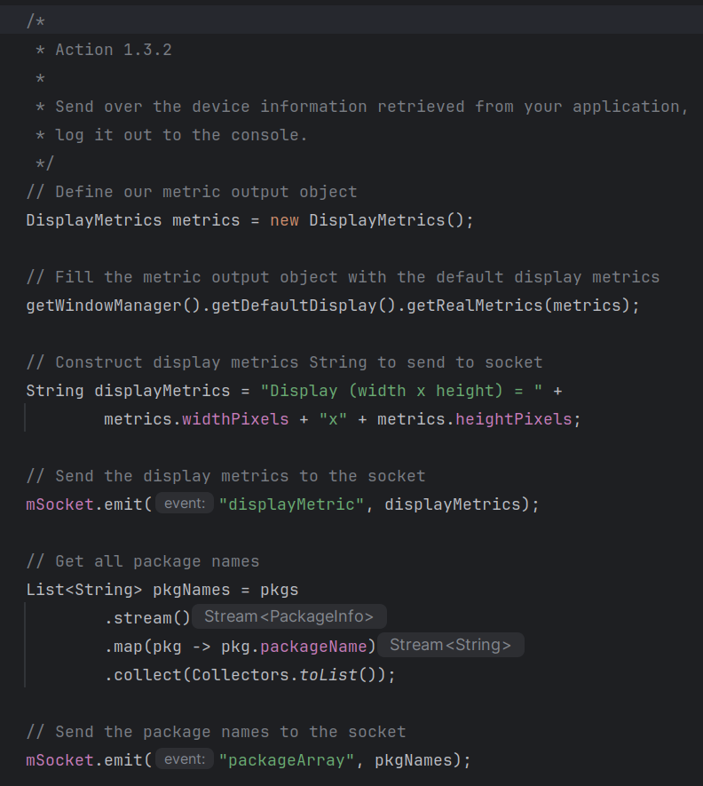
The above code is placed at the end of the MainActivity.java’s onCreate method.

The following code will be in the index.js file where the socket gets created:
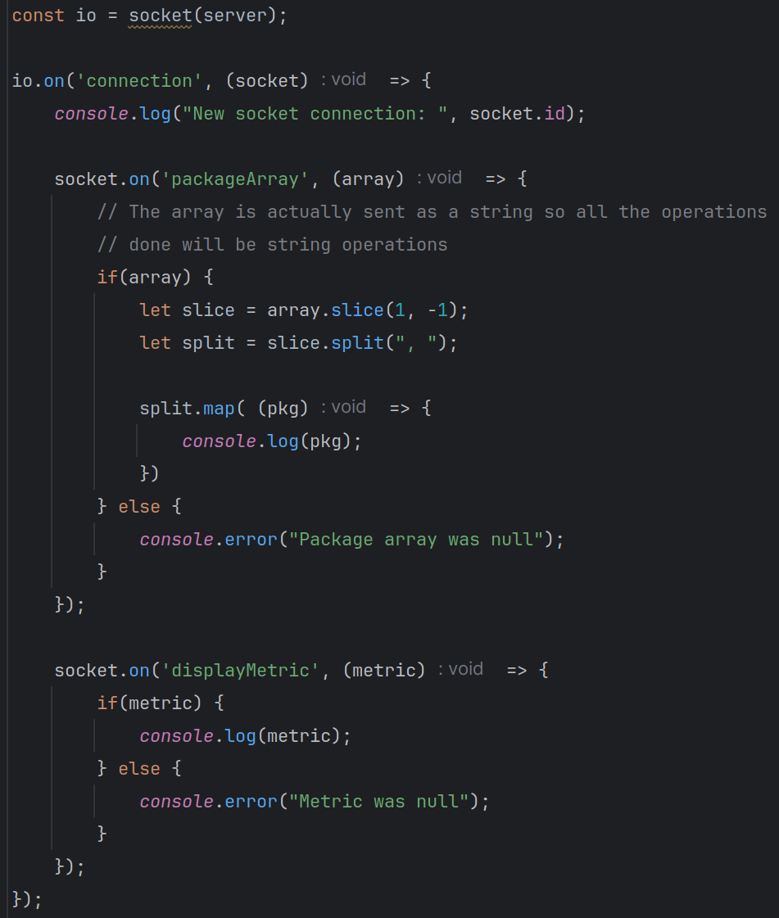
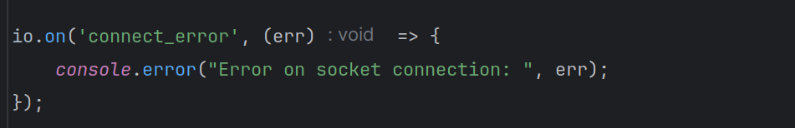
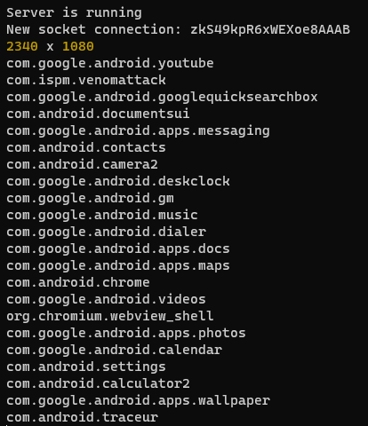
This output is from a different implementation but the only difference is the DisplayMetrics were printed in height x width whereas in the code above it gets printed in width x height.
Task Set 2:
(Description of the task and how you completed it. Include words and images as necessary)

Task 2.1: Accessing Device via ADB Shell
Action 2.1.1
Retrieve the launch activity of the target application and the respective login page that you will utilize in the Appium server and submit a screenshot of your terminal output.

Task 2.2: Connecting to Device Activity via Appium
Action 2.2.1
Connect to the device with the correct parameters and submit a screenshot of your Appium server log reading to you the successful connection
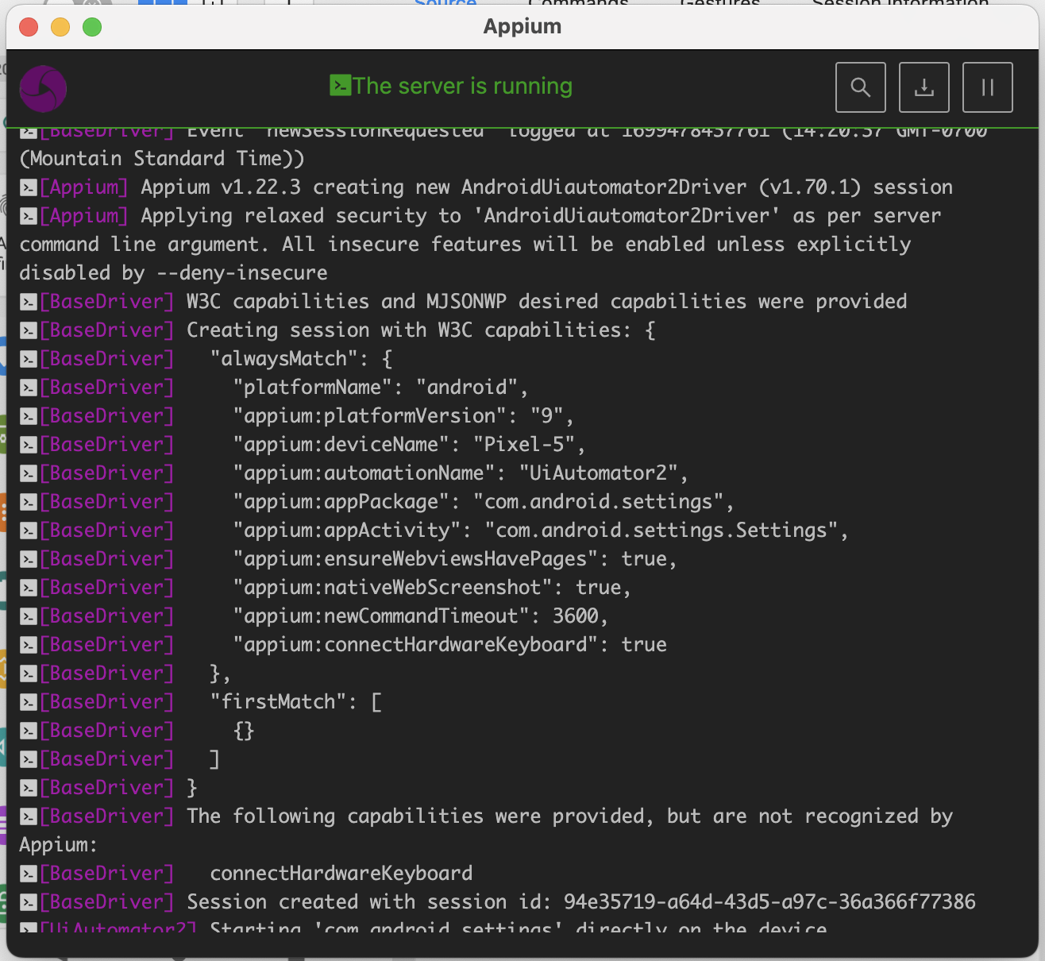
Action 2.2.2
Inspect the layout of your target application. What is the layout of your file? Submit a screenshot.

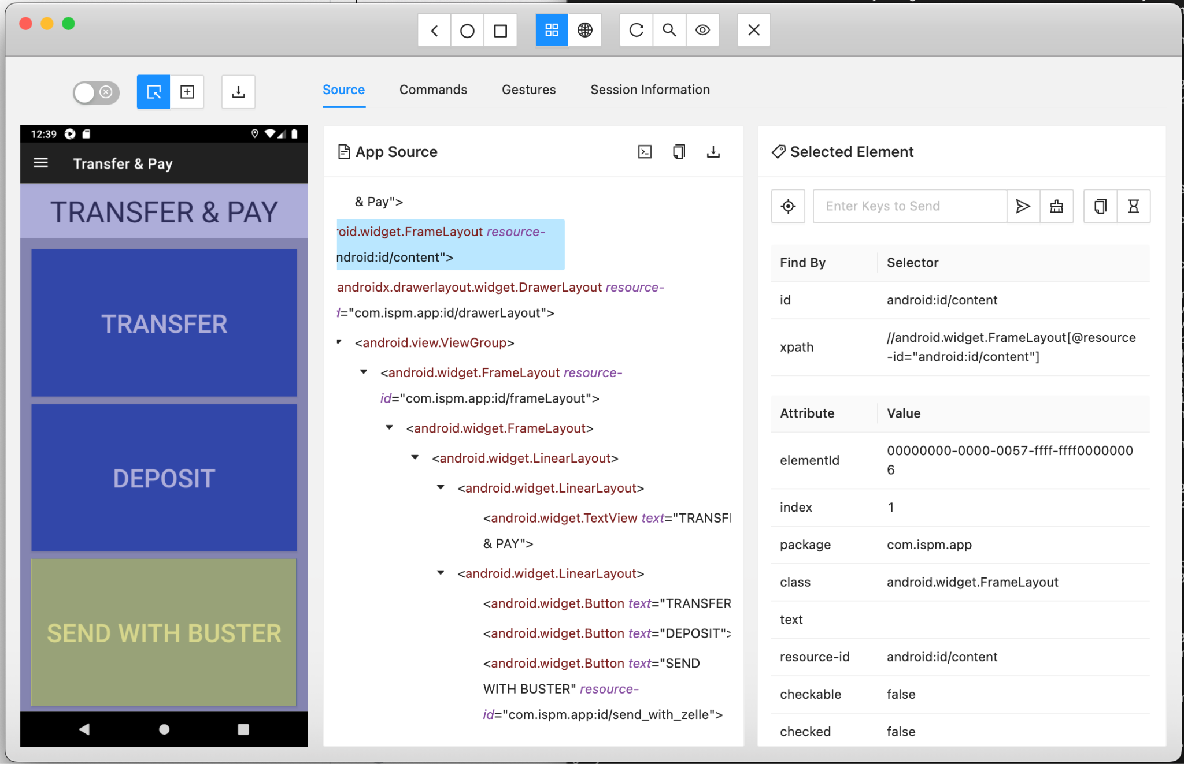

Task 2.3: Generating Fake UI & Patchfile
Action 2.3.1
Take a screenshot of the target application on Appium. Use this as the background image for the layout in Android Studio. Submit a screenshot of your altered layout in Android Studio and a screenshot of your replicated target activity.
- Example:
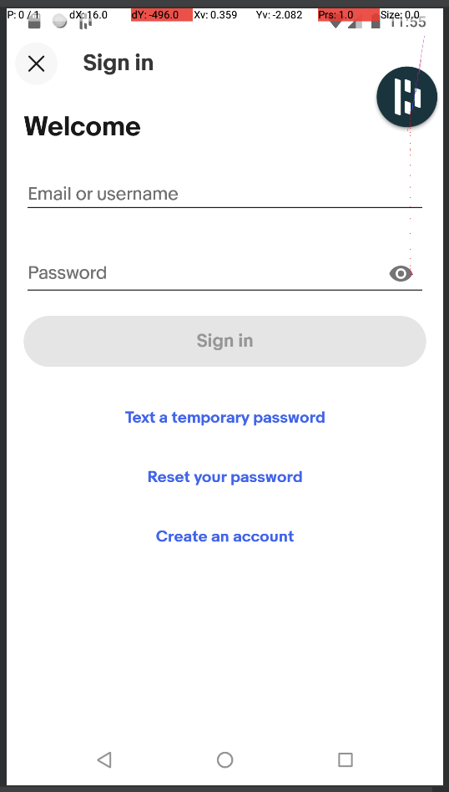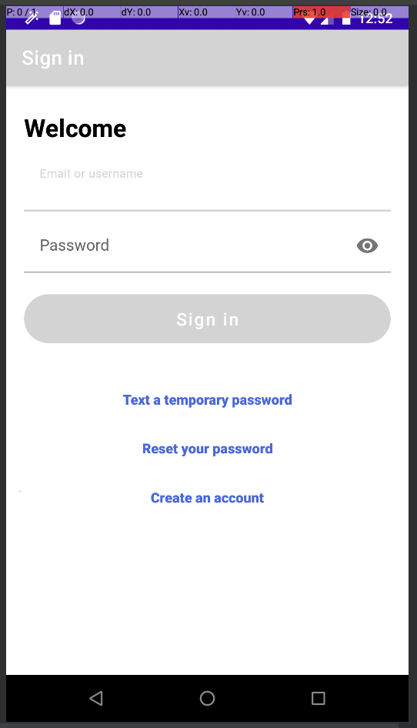
Action 2.3.2
Generate a patch file with your newly updated XML layout for your application and submit a screenshot of both the successful alert message along with the generated layout.
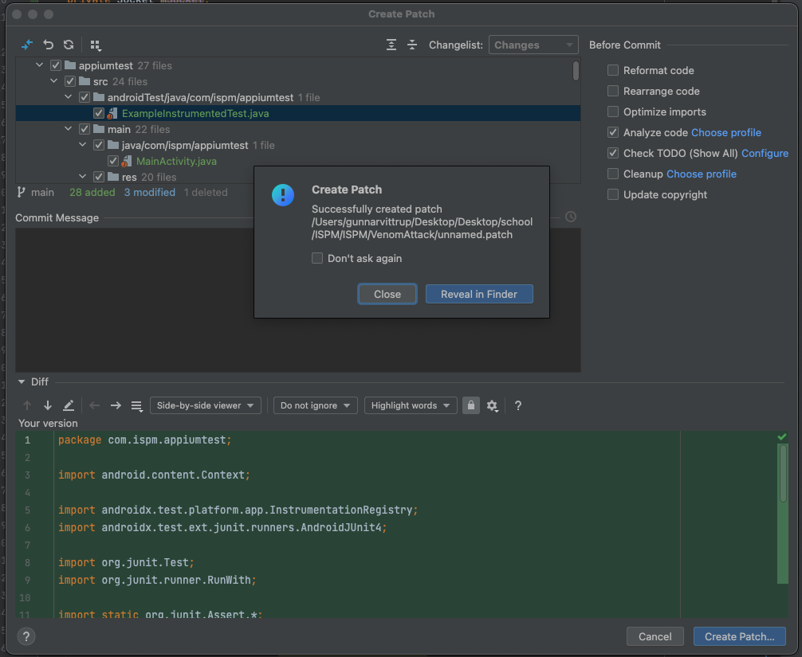
Task Set 3:
(Description of the task and how you completed it. Include words and images as necessary)

Task 3.1: Game Theory
Action 3.1.1
If we were to consider the CDF independently drawn in figure 10 from a symmetric cumulative distribution that is continuous and strictly increasing, what would the cutpoint (c*) be equal to?
- $\frac{1}{2}$ or $0.5$

Action 3.1.2
Substitute each inequality in for x and derive the system of equations for both p and q. What are these equations?
- Player 1’s:
$Θ_{1}>\frac{2-3p}{ϵ}$
$q=1-\frac{(\frac{2-3p}{ϵ})+1}{2}$
$q=\frac{1}{2}-\frac{1}{ϵ}+\frac{3p}{2ϵ}$

- Player 2’s:
$Θ_{2}>\frac{4-5q}{ϵ}$
$p=1-\frac{(\frac{4-5q}{ϵ})+1}{2}$
$p=\frac{1}{2}-\frac{2}{ϵ}+\frac{5q}{2ϵ}$

Action 3.1.3
Substitute 0 in for ε to calculate the probabilities for both p and q. What are the probabilities p and q?
- Player 1’s:
$q=\frac{1}{2}-\frac{1}{ϵ}+\frac{3(\frac{1}{2}-\frac{2}{ϵ}+\frac{5q}{2ϵ})}{2ϵ}$
$q=\frac{2ϵ^{2}-ϵ-12}{4ϵ^{2}-15}$
$q=\frac{4}{5}=0.8$
- Player 2’s:
$p=\frac{1}{2}-\frac{2}{ϵ}+\frac{5(\frac{1}{2}-\frac{1}{ϵ}+\frac{3p}{2ϵ})}{2ϵ}$
$p=\frac{2ϵ^{2}-3ϵ-10}{4ϵ^{2}-15}$
$p=\frac{2}{3}=0.\underline{6}$

